Flack Friday is here



-50%



**VitalDermax**  
LOVES ITS CLIENTS!

Black Friday 2019 is coming SOON - take advantage of our hot sales.

Get **2 for the price of 1** - Pay NOW **only 69 lv** for two packs VitalDermax instead of 138 lv.

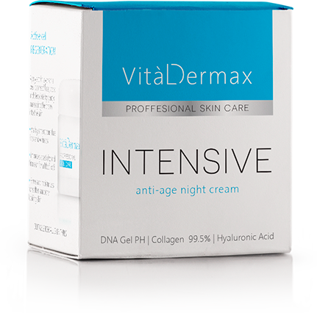

The offer is for you as our loyal clients and ITS VALID ONLY for the next 24 hours.

Name  (enter your name)

Phone  (enter your phone)

ORDER NOW (button)

Remaining **ХХ** days **ХХ** hours **ХХ** minutes **ХХ** seconds